**Release Notes**

**neuroShare Code Drop 4 (10/25/2017)**

1. **Introduction**
   * This neuroShare Code Drop 4 is the second to last code drop in the series of planned releases for v1.0 of neuroShare application. It builds on the functionality released in the previous code drops by adding 25’ Walk component, adding data layer 2 popups for the Lab Orders component, and enhancing the charts displayed.
   * To launch the application, enter URL for the server/port where the application was published
     + Include query string parameters needed by the Demographics component (PatID, CSN, and Username)
     + Other parameters needed by the Graph components are hardcoded in the application (for now) to specify values for pom id and CSN for which mock data has been created

Example URL should look like: <http://localhost:8316/?PatID=1979660&CSN=865482572&Username=CANNONS>

* + The user interface should look similar to the following:

|  |  |
| --- | --- |
| Data Layer 1 | Data Layer 2 |

1. **New Functionality**

|  |  |  |
| --- | --- | --- |
|  | **Implemented Functionality** | **Omitted Functionality** |
| Lab Orders | * Display Data Layer 2 for Lab Orders in collapsible panel with component values, range, trend Sparkline and color coding. * Procedure Codes in configuration file to filter lab results from API |  |
| 25' Walk | * Data Layer 1 showing 25' Walk test results plotted on a line graph. The scale of the Y-axis on the right will adjust based on data values to be plotted. * Data Layer 2 displaying details of a data point with Update facility * Add new data points for 25' Walk test | * Validation of values entered for any component will be addressed in Code Drop 5. For example, currently you can enter values > 300 secs when adding/updating a data point for 25' Walk Test |
| Graph Enhancements | * Zoom time scale on the X-axis of the graphs between 3 years and 1 month * Undo/Reset functionality | * Timeline scrolling * Reference lines with logic for on-day or >1 day logic * Symbols legend |
| Analytics and Progress Notes | * All checkboxes in left "MS Related Panel" generating analytics events to be logged | * Push to progress notes not completed and deferred to next code drop. |

1. **Known Issues**
   * 25’ Walk:
     + Data Layer 2 field "Recorded" to show the date of the test has not be implemented (it is specified in the Spec but missing in Mockup, so a clarification was needed)
     + Validation of values entered not implemented. Currently you can enter values > 300 secs when adding/updating a data point for 25' Walk Test.

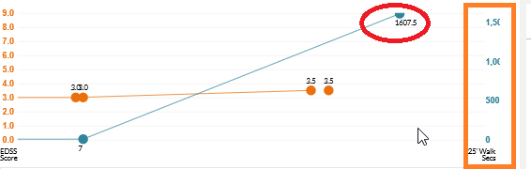

* + The information displayed when clicking on information icon in Data Layer 2 does not have line breaks at the correct locations as shown in the mockup. This information is coming from API response, which needs to be fixed.

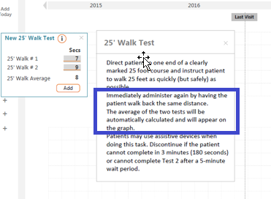

* + Graph:
    - EDSS data points with score less than or equal to 1 are not displaying properly due to SVG clip path issue
    - Legend and Zoom icons need to be changed
  + Other Meds:
    - Generic names labels getting overlapped when the dates are too close to each other

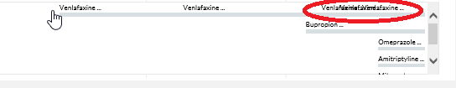

1. **Testing Approach and Results**

Refer to the following documents for Test Plans and Results for Code Drop 4 (including Bug fixes for Code Drop 3). These documents should exist in the same location as this Release Notes document.

|  |  |  |
| --- | --- | --- |
| Test Plan | *<<* *Test Plan MS SHARE-Neuroshare 25' Walk v1.0.docx>>* | *<<Test Plan MS SHARE-Neuroshare Labs v1.0.docx>>* |
| Test Results | *<<* *Test Scenarios MS SHARE-Neuroshare 25’ Walk v1.0 20171025.xlsx>>* | *<<Test Scenarios MS SHARE-Neuroshare Labs v1.0 20171009.xlsx>>* |
| Bug Report | *<<* *MS-Share Defect Tracker_10-20-17 JL-61889.xlsx>* |  |